|  |  |  |  |  |  |  |  |  |  |  |  |  |
| --- | --- | --- | --- | --- | --- | --- | --- | --- | --- | --- | --- | --- |
| A | M | M | S | U | P | L | A | L | M | J | N | H |
| S | L | I | D | L | M | N | O | S | M | P | O | B |
| D | E | S | O | B | E | D | I | E | N | C | I | A |
| S | L | E | R | W | X | L | M | H | R | J | F | A |
| U | C | R | A | P | E | Z | A | M | A | M | N | L |
| P | D | I | C | S | G | J | K | F | C | N | M | L |
| L | G | C | I | C | V | E | G | R | A | A | V | L |
| I | V | O | O | P | O | S | L | H | O | D | S | O |
| C | N | R | N | N | B | S | K | F | T | U | D | R |
| A | Y | D | Y | G | E | Q | X | J | G | I | C | A |
| N | R | I | J | D | S | W | Z | J | S | L | A | P |
| M | K | A | M | A | D | F | N | Y | N | C | J | U |

# SOPA DE LETRA

1.DESOBEDIENCIA

2.PEZ

3.MISERICORDIA

4.ORACION

5.SUPLICA

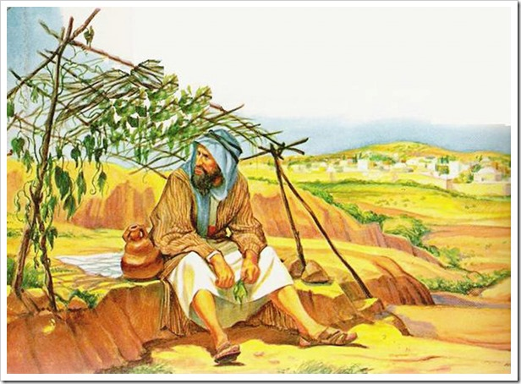6.OBEDIECIA

NOMBRE:

FECHA DE CUMPLE:

CODIGO:

IGLESIA: